**COSC2406**

**Assembly Language Programming**

**Assignment 4**

**Programing General Requirements:**

* Comments are important. All programs must be fully commented on using the format shown throughout class and the textbook in the code examples.
* Submit all your .asm files and running screenshots for questions to Bspace.
* Programs which do not have running screenshots will have a penalty of up to 30%.

1. [10] Revise the encryption program in the following manner: Create an encryption key consisting of multiple characters. Use this key to encrypt and decrypt the plaintext by XORing each character of the key against a corresponding byte in the message. Repeat the key as many times as necessary until all plain text bytes are translated. Suppose, for example, the key was equal to “ABXmv#7.” This is how the key would align with the plain text bytes:

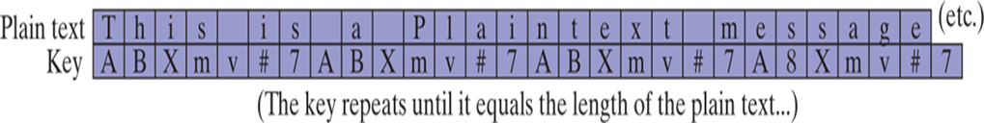

1. [10] The greatest common divisor (GCD) of two integers is the largest integer that will evenly divide both integers. The GCD algorithm involved integer division in a loop, described by the following pseudocode:

int GCD (int x, int y)

{

x=abs(x)

y=abs(y)

do {

int n= x%y

x=y

y=n

} while (y>0)

return x

}

Implement the function in assembly language and write a program to call the function and pass different values. Display your results.